GFWC Florida
1895 Society
Donation Form

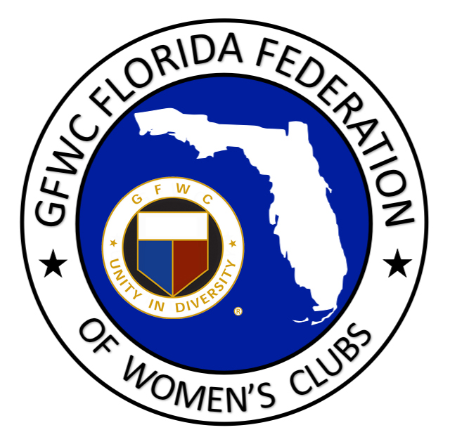

GFWC Florida Headquarters is located at 4444 Florida National Drive, Lakeland, Florida. Our headquarters building was dedicated on May 6, 1990. The building presently houses the President’s meeting room, office, board meeting room, archive storage, living room, kitchen, bathroom and storage room.
Generous donations from clubs and members enable us to continue to maintain and improve our headquarters home into the future. We are grateful for your support!

The 1895 Society – Preserving Our Past and Ensuring Our Future

First time contributors will receive a key pin and a year charm.
Renewals will receive a current year charm to add to your key pin.

NAME:

STREET ADDRESS:

CITY/STATE/ZIP:

PHONE:

EMAIL:

CLUB NAME:

DISTRICT #:

INDIVIDUAL OR CLUB ORDER?:

KEY PIN AND CHARM OR CHARM ONLY:

UNITY LEVEL: ☐ $18.95
LIBERTY LEVEL: ☐ $189.95
CHARITY LEVEL: ☐ $1,895.00

Make check payable to GFWC Florida and mail to:
GFWC Florida
4444 Florida National Drive
Lakeland, FL 33813

Thank you!

